Natalie Neysa Jessica Soesanto (71241079)

1. Latihan :

INPUT nilai_tugas, UTS, UAS

nilai_akhir = (nilai_tugas * (60/100)) + (UTS * (20/100)) + (UAS * (20/100))

IF nilai_akhir > 70

PRINT ("Selamat anda sudah lulus!")

ELSE

nilai_akhir = nilai_akhir + 5

ENDIF

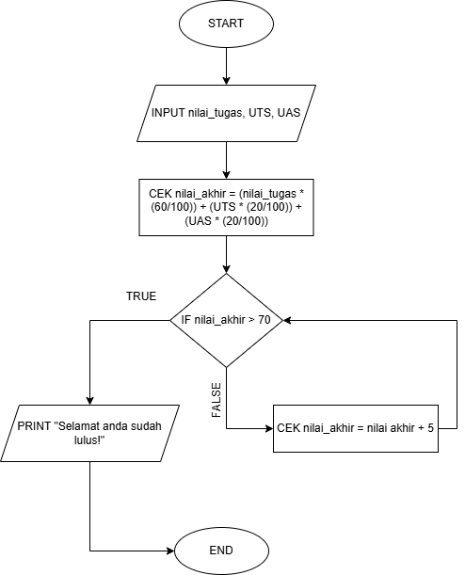

1. Guided :

SET n = 10

SET cn = 1

SET bil = 50

WHILE cn <= n do

bil = bil + 2

PRINT bil

cn = cn + 1

ENDWHILE

